Muhammad Naimat Ullah Khan

21K-4540

LAB 12

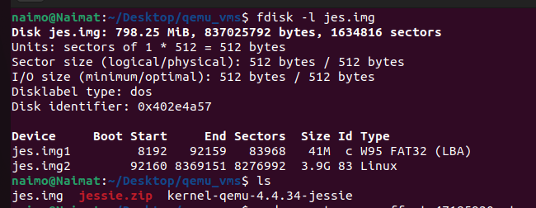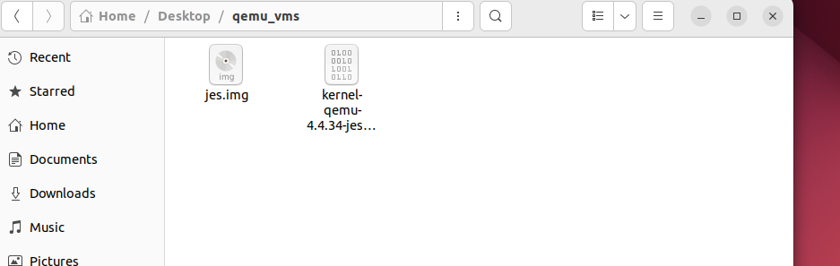

FROM BELOW ONWARDS COMMANDS NOT WORKING IN VIRTUAL MACHINE:

